**Rhythmic Tunes_your melodic companion**

|  |
| --- |
| Team ID: NM2025TMID39551 |
| Team Leader: Aparna R -vishalaparna812@gmail.com |
| Team Members: |
| SWETHA. L -Sweswethaswetha@gmail.com |
| KEERTHANA. A -keerthiarumgam2006@gmail.com |
| JEEVALAKSHMI .S -ljeeva773@gmail.com |

# 1. INTRODUCTION:

The project 'RhythmicTunes' is a web-based music player application designed to provide users with an engaging experience for listening to and managing their favorite songs.

# 2. PROJECT OVERVIEW:

Purpose: RhythmicTunes allows users to play, pause, search, and manage a playlist of songs in a visually appealing interface with an animated gradient background.

Features:  
- Play, pause, previous, and next song controls  
- Playlist display with clickable items  
- Search functionality for songs by title or artist  
- Animated gradient background  
- Real-time progress bar updates

# 3. ARCHITECTURE:

Frontend: HTML, CSS, JavaScript (Vanilla JS)  
Backend: None (static frontend project)  
Database: None (predefined playlist stored in JavaScript array)

# 4. SETUP INSTRUCTIONS:

**Prerequisites:**  
- Any modern web browser (Google Chrome, Firefox, Edge)  
- Text Editor (VS Code or Sublime Text)  
  
**Installation Steps:**  
1. Save the project files in a folder.  
2. Open the HTML file in a web browser.  
3. The application will run directly without a backend.

# 5. FOLDER STRUCTURE:

RhythmicTunes/  
|-- index.html  
|-- style.css (optional if separated)  
|-- script.js (optional if separated)

# 6. RUNNING THE APPLICATION:

1. Open the 'index.html' file in a web browser.  
2. The RhythmicTunes player interface will load.  
3. Use the controls to play songs and explore features.

# 7. USER INTERFACE:

The UI includes:  
- Header with project title  
- Song information section (title and artist)  
- Progress bar showing playback progress  
- Controls for play/pause, next, and previous  
- Search box for filtering songs  
- Playlist showing available tracks

# 8. TESTING:

Testing was conducted manually using Chrome Developer Tools to ensure that songs load, play, and pause correctly. The playlist and search functions were verified with multiple test cases

# 9. FUTURE ENHANCEMENTS:

Future plans include:  
- Adding user-uploaded songs  
- Integration with external music APIs  
- Shuffle and repeat features  
- Responsive design for mobile devices  
- Volume control and mute button

# 10.SCREENSHOT:

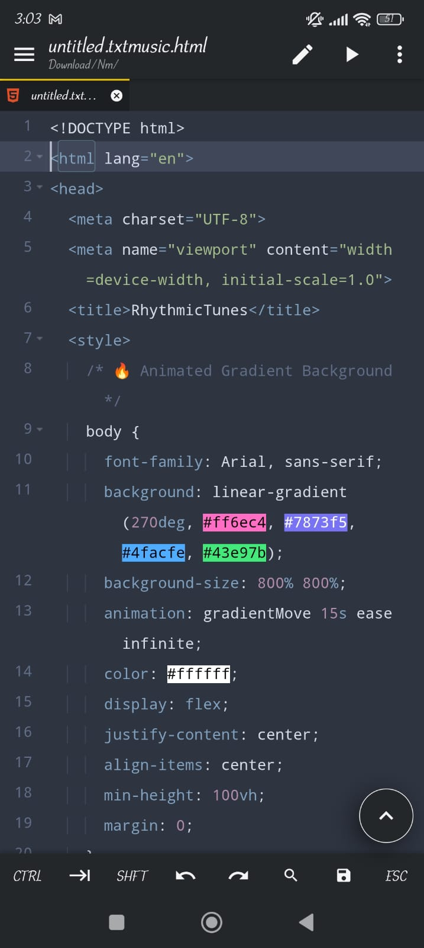

**OUTPUT**

**INPUT**

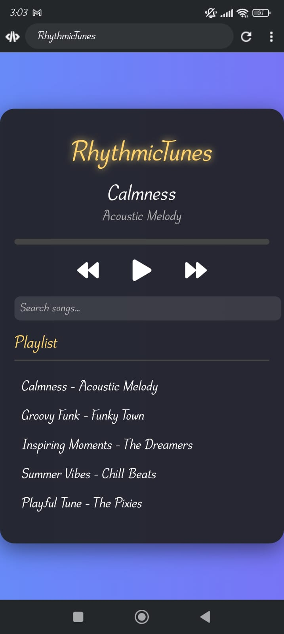

# 11.KNOWN ISSUES:

No backend integration: The project currently runs only on the frontend, so songs must be predefined in the code. Users cannot upload or store their own tracks.

Limited song collection: Only a small set of demo songs are available (from Bensound). No option to expand dynamically.

No mobile optimization: The interface is not fully responsive, so it may not display correctly on smaller screens.

# 12.CONCLUSION:

The RhythmicTunes project successfully demonstrates the development of a simple yet interactive web-based music player using HTML, CSS, and JavaScript. It provides essential features such as play, pause, next/previous track, real-time progress updates, playlist management, and a search option. The visually appealing gradient background and intuitive interface make the application engaging for users.

While the project meets its primary objectives, there are limitations such as the absence of backend integration, restricted song collection, and lack of advanced features like volume control, shuffle, and repeat. These areas provide opportunities for future improvements.